MID-MONTH REVIEW – MARCH 2021

Philip Nothard, insight & strategy director for Cox Automotive UK, shares his brief observations on the car market trends this month.
OEMs find workarounds to semiconductor shortage
The global semiconductor shortage continues to impact new car production lines. It is expected to hit both revenues and new car supply over the coming months, with a leading car manufacturer citing the disruption could cost several billion dollars. OEMs are searching for workarounds to the shortage, and General Motors have recently announced they won't be producing fuel economy models within their pickup line-up for the time being as these rely on the semiconductors.

All this comes as the SMMT downgrades its new car forecast for the second time in 2021 to 1.83 million registrations on the back of restricted Q1 trading. February results were the weakest the sector has seen since 1959 with -35.5% (28,282) fewer cars registered. We anticipate another 150k lost compared to an average crucial new plate March month while showrooms remain closed.

Possible DVLA strike action could cause headache for dealers
Hundreds of workers at the DVLA have voted for industrial action after the Swansea office saw over 500 COVID-19 cases since September. While this is certainly understandable considering the circumstances and it is a horrible situation for DVLA workers, the strike action could come at a bad time for dealers who are counting down the days for showrooms reopening in early April. Although a strike would impact dealers, thankfully the impact will be lessened with many processes now being carried out online.

Used car prices and demand return to pre-lockdown #3 levels
The used car market continues to perform strongly given the circumstances with prices and demand reaching their highest levels of the year so far. While supply volumes remain behind March 2020, there are signs of optimism within the dealer network with weekly upswings as retailers review, replenish and increase stock levels ahead of a physical reopening date.
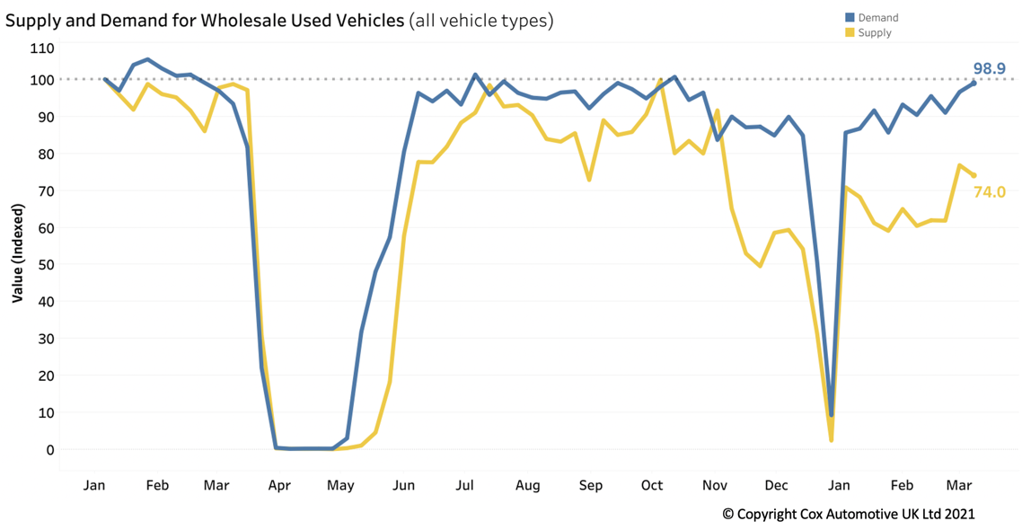
Increased demand has seen prices rise from lockdown levels; however, we are unlikely to see the same pent-up demand as showrooms reopen this time compared to last summer. Therefore, used car prices are forecast to remain stable.
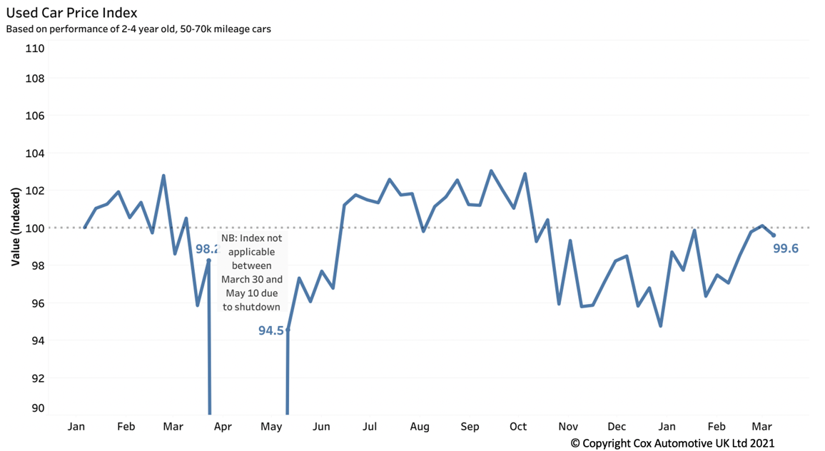
Auctions see recovery despite lockdown still being in place
With the government providing a clear roadmap out of lockdown, retailers have been able to plan accordingly, causing an early rise in auction activity. Retailers have brought buyers back from furlough and are reviewing stocking levels ahead of the 5th April physical showroom reopening in Scotland and 12th April in England.
While performance remains slightly behind March 2020 levels, there are signs of a return to normality with big month-on-month increases to key figures. The first 14 days of March compared to February have seen an increase to auction volumes (+12.48%), CAP clean performance (+1.72%) and first-time conversions (+8.93%).

Ends.

For all media enquiries and picture requests,
please contact: tim.gearey@coxauto.co.uk | 07712 557 867

About Cox Automotive UK
Cox Automotive is the world's largest automotive service organisation. We provide dependable solutions that improve performance and profitability throughout the vehicle lifecycle, to manufacturers, fleets and dealers. Our businesses are organised around our customers' core needs across vehicle solutions, remarketing, funding, and retail. Cox Automotive brands in Europe include Manheim, Manheim Express, RMS, Dealer Auction, NextGear Capital, Modix and eVA Valuations & Appraisals. For more information, visit www.coxauto.co.uk

